1. Introduction
   1. What is a neural network?
   2. Supervised learning with neural networks
   3. Why is deep learning taking off?  
      About this course
   4. FAQ: Reading
   5. Course Resources

Python:

* TensorFlow
* Keras
* PaddlePaddle
* CNTK
* Caffe



**Introduction**

**What is a neural network?**

Find a function that fits data of size of house to prices

Simplest neural network

Neuron -input a size, computer LF, take max of ‘0’ and outputs estimate of price.

This is a ReLU function – rectified linear unit. Rectified just means taking a max of ‘0’. A larger network is formed by taking many of these neural networks and stacking them together.lin

Bigger neural network

Each node is a ReLU. I below example, you provide the x and y and the algorithm will figure out the hidden part, e.g. family size, etc.

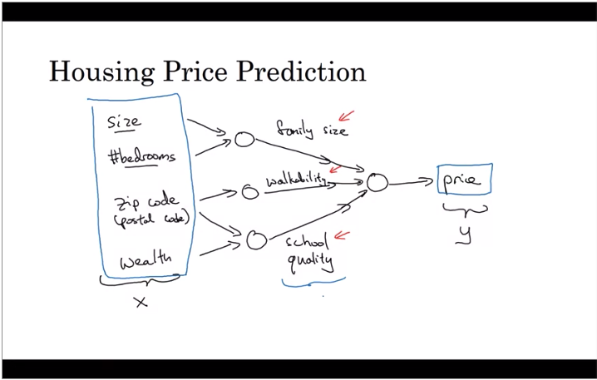

Input and hidden layer are density connected.

Supervised learning with neural networks

Ability to show ads that you are more likely to click on.



Types of neural networks for applications/usage:

* Predictions - home price, advertising (standard NN)
* Image app (CNN)
* Audio – 1-D sequence data with temporary component (RNN)
* Speech recognition, translation (RNN)
* Autonomous driving (Custom/hybrid)



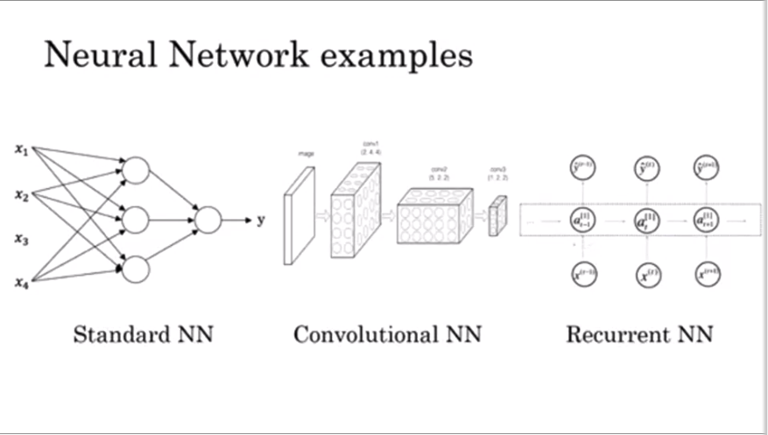

Application of ML to structured (DB, columns, rows, etc) and unstructured data

Structured—each feature is well defined.

Unstructured – audio, image, text



Why is Deep Learning taking off?

Why is DL working so well?  
Plotting LAlgo performance related to amount of data. We have accumulate more data and can feed these algos to learn.





Can see in chart above, that in order to get higher performance –need higher NN and more data. Label is input x and output y (x,y). m is sample size



Switching form sigmoid to ReLU to make computation faster. Challenge is that learning becomes slow when sigmoid is near 0. ReLU – gradient is equal to 1 for all positive values of input—so gradient is less likely to gradually shrink to zero.





WK 1: Intro

WK 2: NN programming

WK 2: 1 hidden NN layer

WK 4: Deep NN

Geoffrey Hinton